**Electric Circuits Experiment**

**Report 1 – Basic concepts and laws**

**Preview 03 – Superposition Theorem and Homogeneity Theorem**

**Name:** Vinura Sudantha Pathirana

**Student ID:** 2019380204

1. **Under what condition does the homogeneity theorem not hold true? Describe two possibilities: a) We need to replace element, b) We don’t need to replace element to satisfy homogeneity, design an experiment to prove that.**

***Solution***

1. **a)**

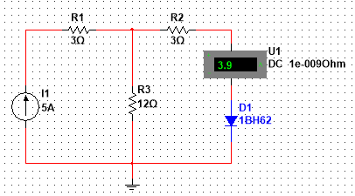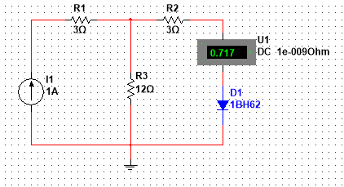

Looking at these two circuits and observing its measurements, we can clearly see that homogeneity does not hold in non-linear circuits. Even though the current source was increased by 5 times, the final current flow was not increased by 5 times, thus, proving the earlier point.

1. 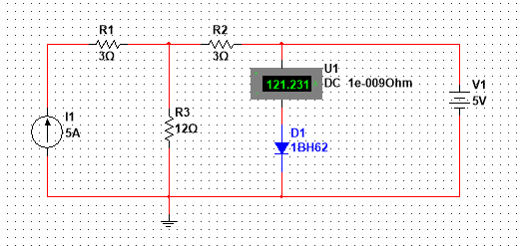**b)**

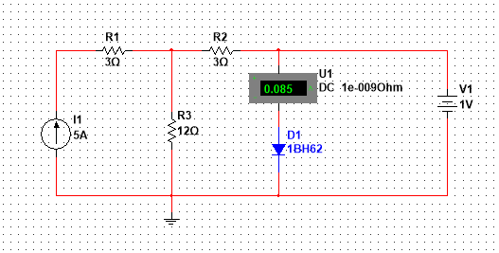

Observing these two circuits, it is clear that the homogeneity theorem does not hold if we just amplify one source and leave the rest untouched. We observe from the above circuits that when we amplify the voltage source by 5 times, the current is amplified by a number much larger than 5, thus proving our above point.

**2. Under what condition does the superposition theorem not hold true? Describe two possibilities: a) we need to replace element, b) we don’t need to replace elements to satisfy homogeneity, design an experiment to prove that.**

***Solution***

1. **a)**

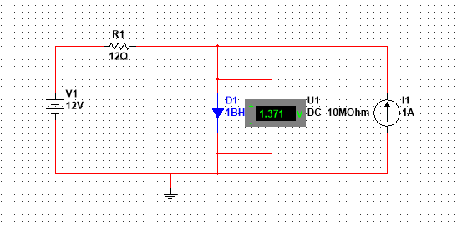

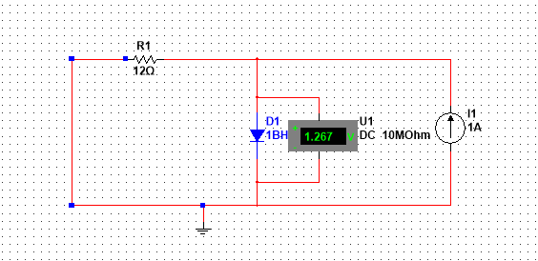

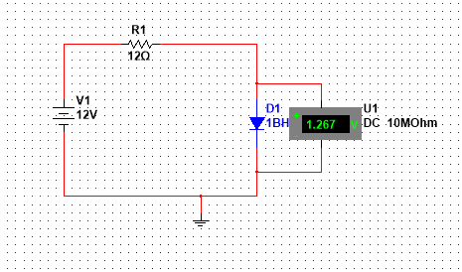

By observing the circuits we have simulated above, it is clear that the superposition theorem doesn’t hold when talking about non-linear circuits. If we were to sum up the two voltages,

**1.267 V + 1.267 V does not equal to 1.371 V**

**2. b)**

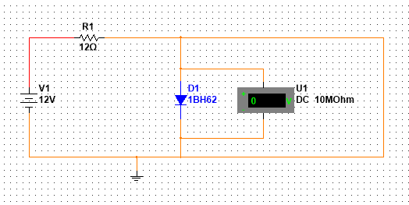

Observing the two circuits given above, it is clear to us that the superposition theorem doesn’t hold if we short-circuit the current source of the circuit.